

**Universidad De las Fuerzas Armadas ESPE**

**Homework 07 User Requirements**

**Team 4: [ CodeCrafting Engineers]**

1. **GABRIEL ANTHONY MOLINA GALLEGOS**
2. **LEYDI ESPERANZA OÑA SUQUILLO**
3. **MARCO ADRIAN PADILLA TRIVIÑO**
4. **DAVID ALEXANDER PILAGUANO CHISAGUANO**

**Link:** <https://youtu.be/uykaysUmZEE?si=HZNSTpS617KPxXcK>

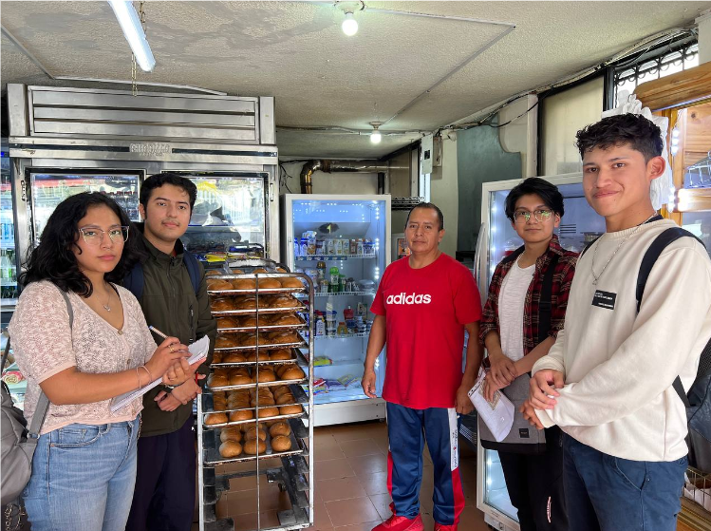

**https://docs.google.com/document/d/1avY4ozfli4qlDfpLc0u19PPhpCLjIc_sG0RfeprL9L8/edit**